**

**MATHEMATICS:**

**SPECIALIST 1 & 2**

**SEMESTER 2 2018**

**TEST 6 - Calculator Free**

Reading Time: 2 minutes

Time Allowed: 18 minutes Total Marks: 18

**1.** [1, 1, 1, 2 marks]

Given that $z_{1}=3+i$ and $z_{2}=2-2i,$ plot (and label) the following points on the Argand diagram below.

(a) $z_{1}+z_{2}$ (b) $\overline{z_{2}}$ (c) $iz_{1}$ (d) $\frac{z_{1}}{z_{2}}$

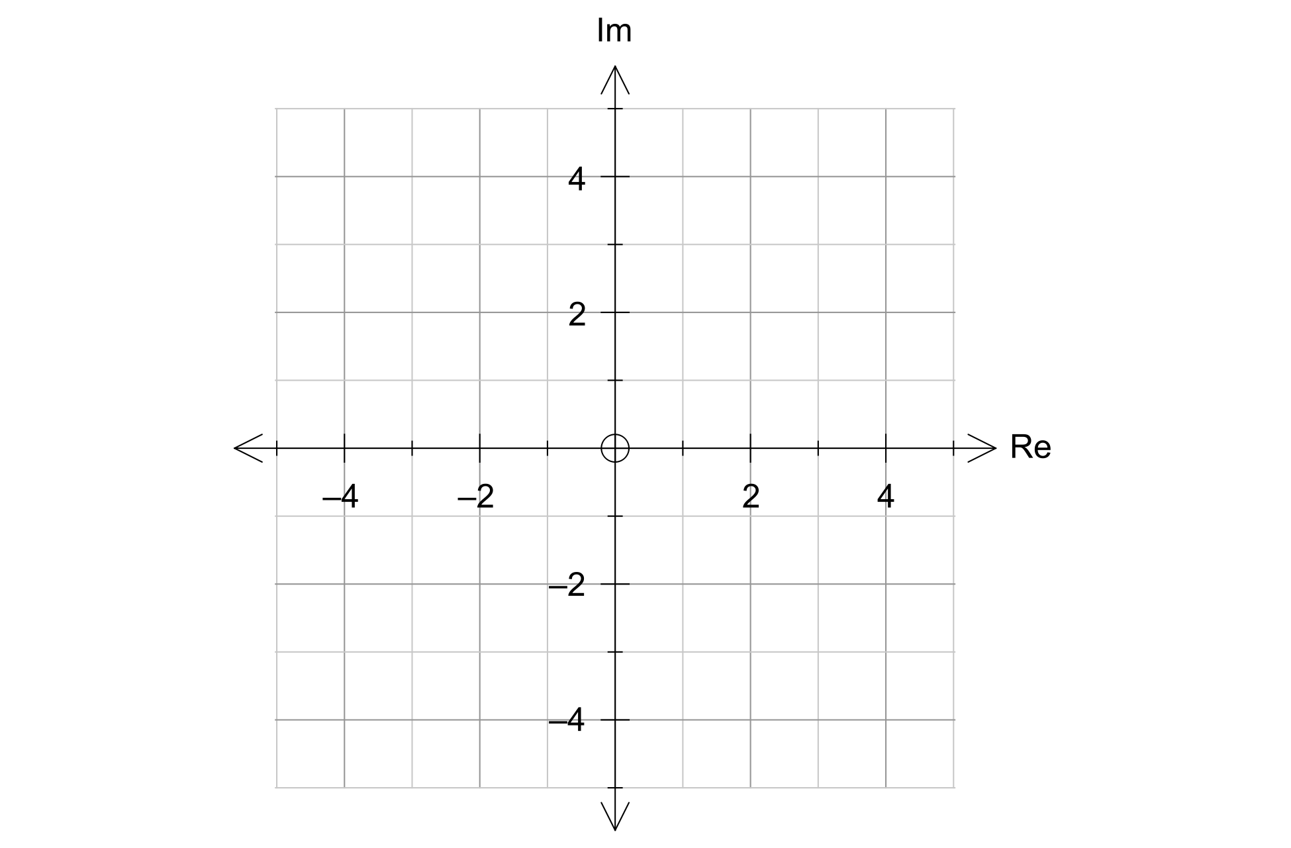

**2.** [3 marks]

The transformation matrix $\left[\begin{matrix}k & 2 \\ 1 & k+1\end{matrix}\right]$ is such that it quadruples the area of any shape that it transforms.

Determine the value(s) of $k$.

**3.** [1, 5, 4 marks]

(a) One factor of $x^{2}+4x+20$ is $(x+2+i4)$. State the second factor.

(b) Solve the following quadratic equations.

(i) $w^{2}+2w+5=0$

(ii) ${(x-3)}^{2}=-5$

(c) Determine the complex number $w=a+bi$, given that $2w+3i\overline{w}=1+9i$.

**

**MATHEMATICS:**

**SPECIALIST 1 & 2**

**SEMESTER 2 2018**

**TEST 6 - Calculator Assumed**

Reading Time: 3 minutes

Time Allowed: 35 minutes Total Marks: 35

**4.** [4 marks]

The Argand diagram on the right shows six complex numbers, $A, B, C, D, E$ and $F$. Four complex numbers, $Z_{1}, Z_{2}, Z_{3}$ and $Z_{4}$ have the following information known about them.

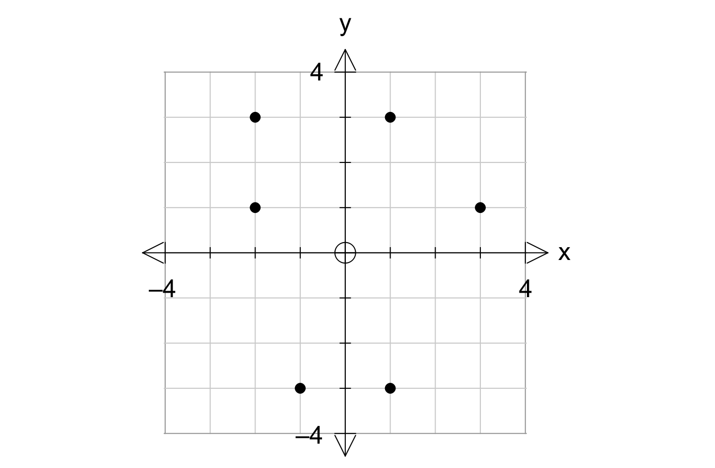

$$A$$

$$B$$

$$C$$

$$D$$

$$E$$

$$F$$

$Re\left(Z_{1}\right)=Im(Z_{2})$

$Z_{3}= \overline{Z_{4}}$

$Z_{1}=iZ_{3}$

Complete the table below by allocating one of $A, B, C, D, E$ and $F$ to each of the complex numbers.

|  |  |  |  |  |
| --- | --- | --- | --- | --- |
| Complex Number | $$Z_{1}$$ | $$Z_{2}$$ | $$Z_{3}$$ | $$Z_{4}$$ |
| Point |  |  |  |  |

**5.** [2, 2, 3, 2 marks]

The quadrilateral with vertices $A \left(0,0\right), B \left(3,1\right), C (3,3)$ and $D (-2,2)$ is transformed by the matrix M= $\left[\begin{matrix}0 & -1 \\ -3 & 0\end{matrix}\right]$ onto the quadrilateral $A'B'C'D'$.

(a) Determine the coordinates of $A'B'C'D'$.

(b) The area of quadrilateral $A'B'C'D'$ is 26.25units2. What is the area of quadrilateral $ABCD$?

(c) Matrix M represents the combination of transformation P followed by transformation Q. If the matrix for transformation P = $\left[\begin{matrix}-3 & 0 \\ 0 & 1\end{matrix}\right]$, determine the matrix for transformation Q and describe the geometric transformation Q represents.

(d) The quadrilateral $A'B'C'D'$ is then transformed by the matrix $\left[\begin{matrix}1 & k \\ 0 & 1\end{matrix}\right]$ such that the image of $C'$ lies on the y-axis. Determine the value of k.

**6.** [1, 1, 3, 2 marks]

A triangle has vertices $A \left(1,2\right), B \left(3,5\right)$ and $C (4,3)$.

(a) Triangle $ABC$ is transformed to $A' \left(1,-2\right), B' (3,-5)$ and $C' (4,-3)$.

(i) Describe the transformation geometrically.

(ii) State the 2 x 2 matrix that will transform $ABC$ to $A'B'C'$.

Triangle $A'B'C'$ is dilated by a scale factor of 3 parallel to the x-axis and then rotated 60° clockwise about the origin to form triangle $A''B''C''$.

(b) Determine the single matrix that will transform $A'B'C'$ to $A''B''C''$.

(c) Determine the single matrix that will transform $A''B''C''$ back to $A'B'C'$.

**7.** [4 marks]

The points $O \left(0,0\right), A \left(3,1\right), B \left(5,2\right)$ and $C (2,2)$ are transformed to the points $O' \left(0,0\right), A' \left(-5,8\right), B' \left(-8,13\right)$ and $C' (-2,4)$ by the matrix T. Determine T.

**8.** [3, 3 marks]

(a) Show that the transformation matrix $\left[\begin{matrix}3 & 1 \\ 12 & 4\end{matrix}\right]$ maps all the points in the plane to a line and determine the equation of this line.

(b) Show that the transformation matrix $\left[\begin{matrix}9 & -3 \\ 3 & -1\end{matrix}\right]$ maps all the points on the line $y=3x-2$ to a single point in the plane and determine this point.

**9.** [5 marks]

Find the image of the line $2x+y-6=0$ after it is reflected in the line $y=-x.$